**Lesson 7 Demo 9**

**Understanding the Working of Node-Specific Volume Limits**



Steps to be followed:

1. Creating a persistent disk

**Step 1: Creating a persistent disk**

* 1. Click the **Disks** button in the **Compute Engine** section of the Dashboard. Leave the default entries as is and click **Create** for the name **sample-disk**

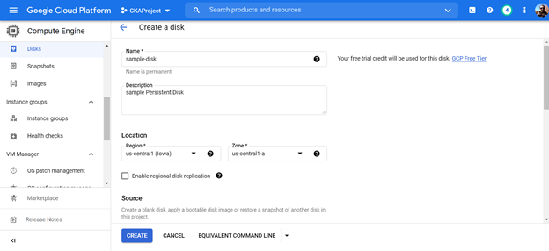

* 1. View the disks in the list

